**Lab 5**

1. Create an Express application that will accept a GET request from route /courses and send a JSON response with courses data.

• Log all requests to a file access.log by creating your own middleware.

• Create another route for the /students. Practice extracting query parameters from this route.

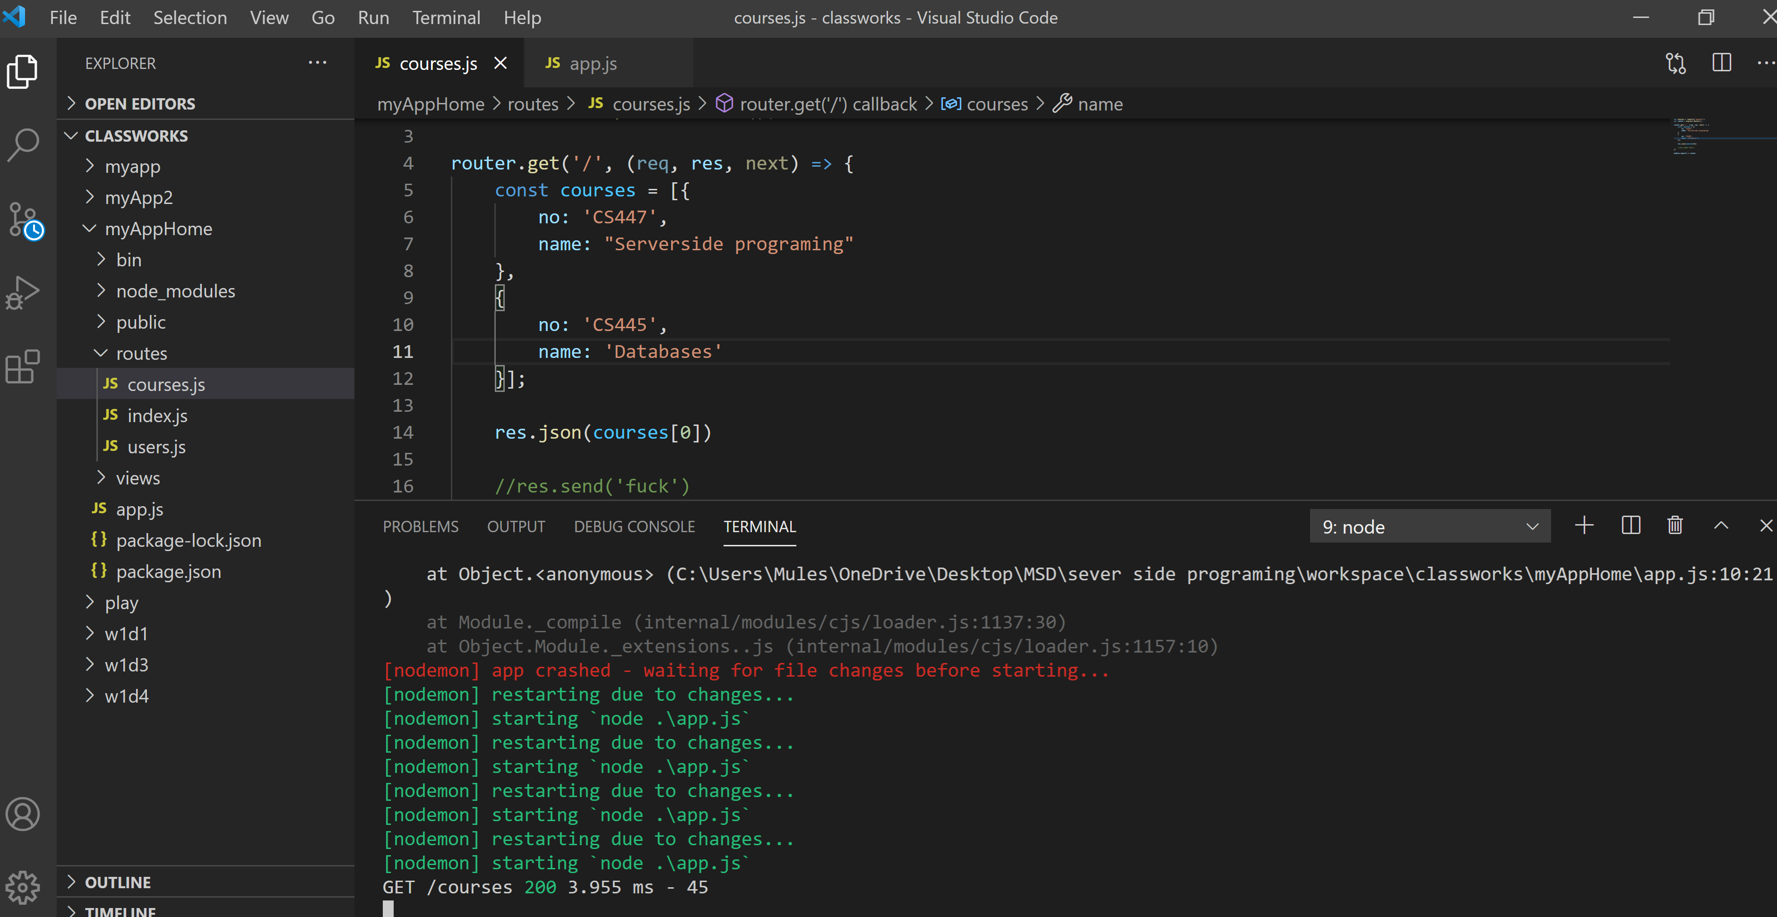

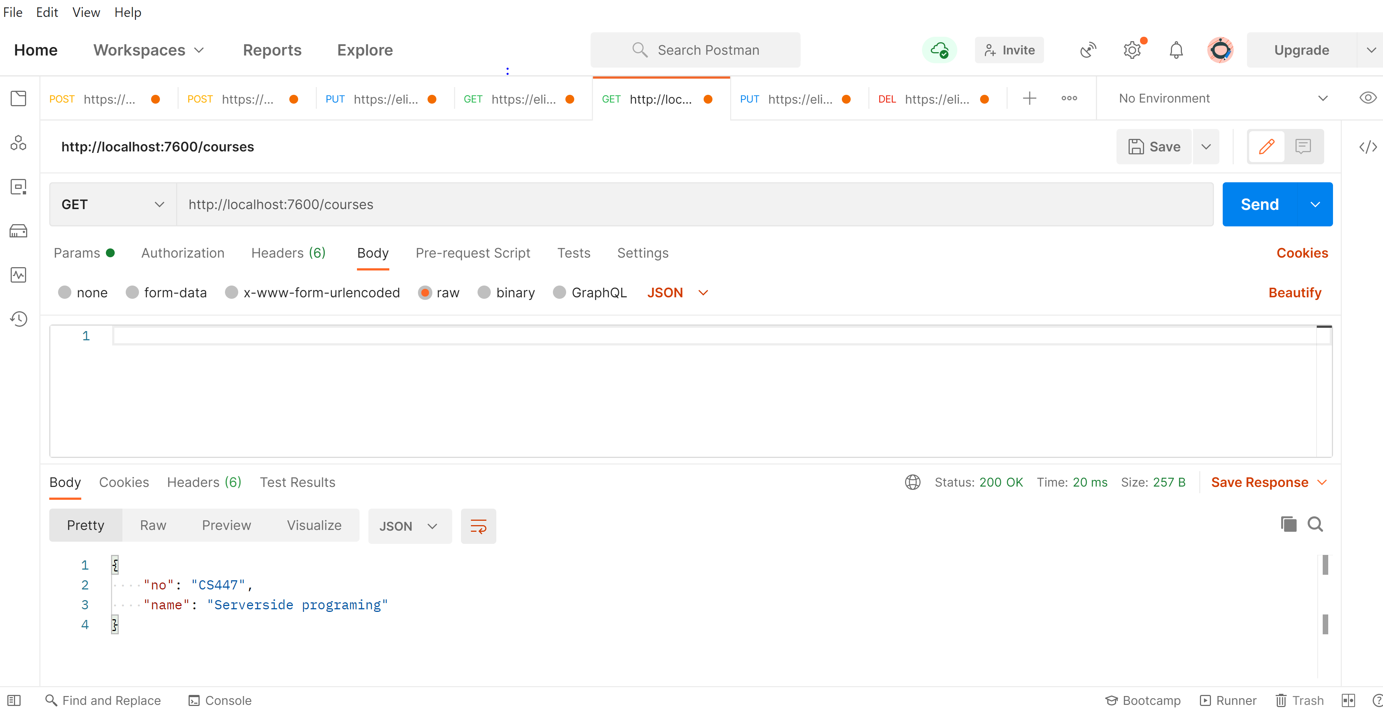

Create another route for the /students. Practice extracting query parameters from this route.

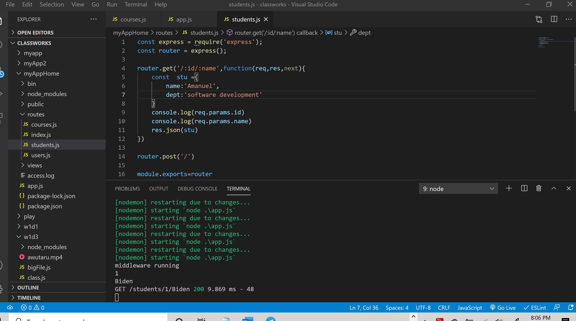

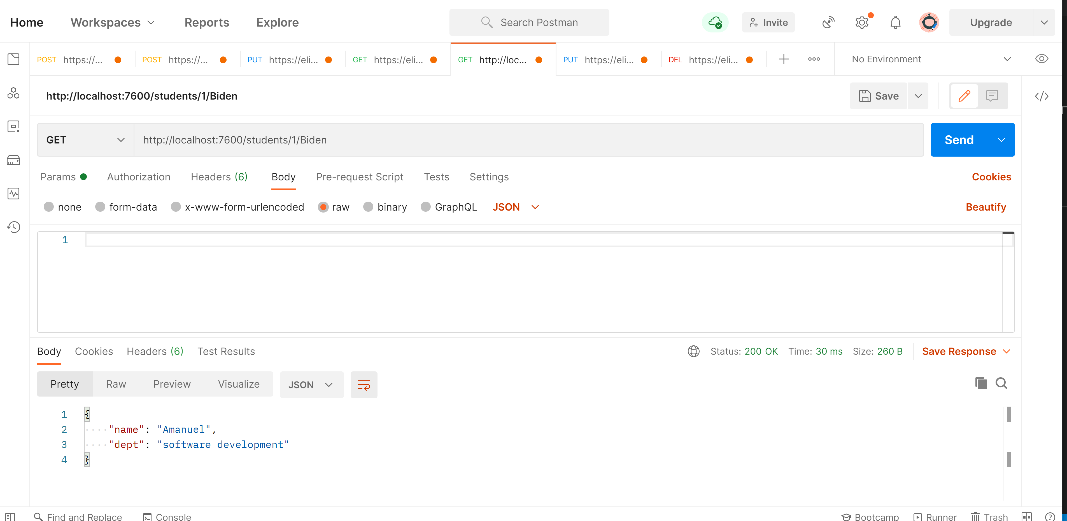

Query param

